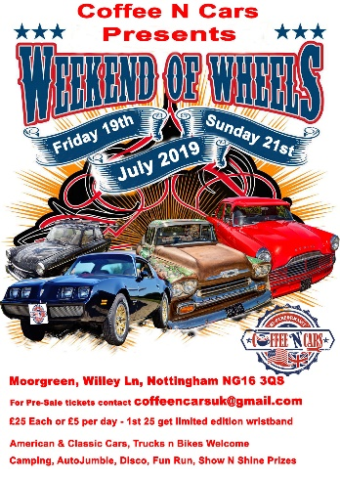
Weekend of Wheels Booking form
July 19-21 2019
Moorgreen Campsite
Willey Lane, Nottingham, NG163QS

Name:
Car Make:
Car Colour:
Reg Number:
Address:

Post Code:
Mobile Number:
Email Address:
Tent or Caravan:
Please note there is no electric hook-ups on the campsite:
Day of Arrival: put an X | Friday: | Saturday: | Sunday:
Qty of tickets req? | £25 Per Person Vendor:  £25 Per Person:  £5 Show Admission:  £10 Day Ticket including wristband for entertainent:

You can pay via online banking with these details, please reference your name and Reg # in the payment.
Natwest Bank - Sort Code: 55-61-17 Account # 68540957
once you have made your payment email this form to the address below.
You can also pay with PayPal https://www.paypal.me/coffeencars Pay as Friends & Family if you need to pay as a business ensure you pay £26.05 to cover PayPal Fee’s
All E-tickets will be sent out via email, and wristbands will be given at the registration tent upon entry.
Contact information for the event is as follows:
Email: coffeencarsuk@gmail.com
Phone:
Dogs are welcome to the site, however you are responsible for cleaning up after your pet, if you are seen not doing so, you may be asked to leave the site.
Please leave the campsite in the same state you found it in, rubbish bags will be provided upon entry, and there will be several large skips to throw your rubbish into.
BBQs will be allowed as long as they are off the ground, No Open Fires are allowed on the campsite.

